**IFT 458/598: Middleware Prog & Database Security**

Anurag Shahare

Module 4 Assignment: Setting up MongoDB in Cloud

Dinesh Sthapit

October 8, 2022

Git: <https://github.com/AnuragShahare/M4A1-Setting-up-MongoDB-in-Cloud->

**Step 1:**

Created database and inserted data to collection:

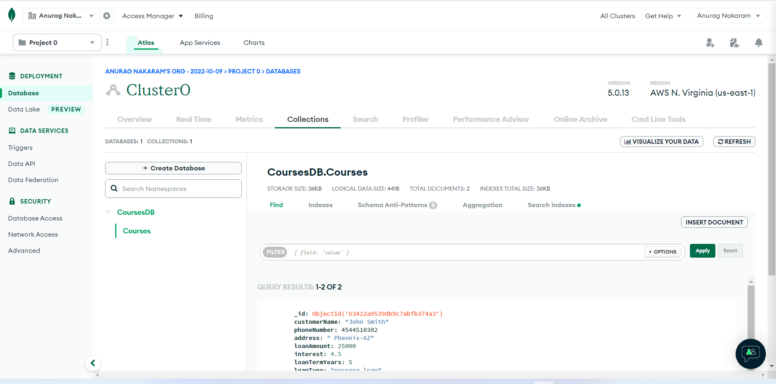

**Step 2:**

Installed node modules:

**Step 3:**

Created a Folder named "schemas". And then, create a file "loanSchema.js

**Step 4:**

**Schema:**

Everything in Mongoose starts with a scheme. Each schema is associated with a MongoDB collection and defines the format of the documents within that collection. Schemas not only define document structure and property casting, but also document instance methods, static model methods, compound indexes, and document lifecycle hooks called middleware.

**Datatypes:**

String

Number

Date

Buffer

Boolean

Mixed

ObjectId

Array

Decimal128

Map

**Step 5:**

**Step 6:**

**a) Just by "CustomerName"**

**b) And another one by "_id"**

